**Bridge to Cerner ORU Requirements**

**Version 2.0**

**Prepared By: Levy Lazarre and Hope Kaczmarczyk**

**Date: 7/30/2019**

Document Control 3

Resources 3

Project Distribution List 3

Document Version Control 3

1. Introduction 4

1.1 Purpose 4

1.2 Project Scope 4

1.3 Terminology Standards 4

1.3.1 Acronyms 4

1.3.2 Glossary 4

1.4 Document References 4

2. Diagram 5

3. Requirements 7

3.1 Functional Requirements 7

3.2 Messaging Protocols 9

3.2.1 Inbound to the BayCare Cloverleaf From Bridge 9

3.2.2 Outbound to Cerner 9

4. HL7 Messaging 10

4.1 Messaging Format 10

4.1.1 Segments 10

4.1*.*2 Messaging Event Types 10

4.1.4 Cloverleaf Site Location 11

4.2 Data Transformation Requirements 11

4.3 Sample Message 11

Appendix A: Risks and Concerns 13

Appendix B: Issues List 13

# **Document Control**

## Resources

|  |  |  |
| --- | --- | --- |
| **Name** | **Role** | **Email** |
| Michael J King | IS Project Manager, BayCare | Michael.King@baycare.org |
| Andrew Miller | System Engineer,  Consulting Advancement Team, Cerner | Andrew.Miller@cerner.com |
| Matthew Awosanya | Technology Consultant, Cerner | matthew.awosanya@cerner.com |
| Michael Harris | Software Engineer, Cerner | Michael.Harris@Cerner.com |
| Nicole Gitney | Director of Nursing Informatics | Nicole.Gitney@baycare.org |
| Debra Armstrong | SR Systems Analyst,  APPS - DOCUMENTATION | Debra.Armstrong@baycare.org |
| Hope Kaczmarczyk | SR Integration Analyst, BayCare EIT | Hope.Kaczmarczyk@baycare.org |
| Levy Lazarre | Integration Analyst, Baycare EIT | Levy.Lazarre@baycare.org |
| Amy S Knight | SR Systems Analyst,  APPLICATIONS ANCILLARY | Amy.Knight@baycare.org |
| Jeff Jung | BayCare Manager Laboratory IT | [Jeffrey.Jung@BayCare.org](mailto:Jeffrey.Jung@baycare.org) |
| Jane K Holz | SR Systems Analyst,  LAB COMPUTER | Jane.Holz@baycare.org |
| Danielle Sawyer | Systems Analyst,  REVENUE CYCLE APPLICATIONS | Danielle.Sawyer@baycare.org |

## Project Distribution List

## Document Version Control

|  |  |  |  |
| --- | --- | --- | --- |
| **Version** | **Date** | **Modifier** | **Description** |
| V1.0 | 01/10/2018 | Levy Lazarre | Original document |
| V1.1 | 01/16/2018 | Hope Kaczmarczyk | Added Cerner information and project diagrams |
| V2.0 | 07/30/2019 | Art schwartz | Cerner Model update |
|  |  |  |  |

# 1. Introduction

## 1.1 Purpose

The purpose of this document is to describe the **ORU** (Results) Interface going from Cerner Bridge Solutions to Cerner Millennium.

Bridge is a Cerner application used by nurses for the management and documentation of breast milk administration to newborns and blood transfusions to hospital patients.

## 1.2 Project Scope

The scope of this project is to automate the integration of the Cerner Bridge Solutions application with the Soarian HIS via HL7 ADT interface and the Cerner EMR via HL7 Orders and Results interfaces. The current document describes the ORU interface, results from Bridge to Cerner Millennium for Breast Milk management and Blood Transfusions.

## 1.3 Terminology Standards

### 1.3.1 Acronyms

**ADT** - Admission, Discharge, Transfer: mainly demographic and patient location data

**BTS -** Blood Product Transfusion Status/Disposition

**DTA** - Discrete Task Assay; reference data item

**HIS -** Health Information System, the source and keeper of patient demographic data

**ORU** - A HL7 Observation Result message

### 1.3.2 Glossary

**ADT Event** – Trigger event associated with a patient event: registration, admission, discharge, transfer, update…

**Alias** - An identifier used to represent an item, such as a location, order, specimen type, or result.

**Bridge** - An external Cerner Solution used by Baycare for Medical Breast Milk/Infant Feeding Management and

Transfusion Administration.

**Contributor System –** External System that sends to and/or receives data from Cerner Millennium. A “Contributor System” is built on Cerner as part of an interface or data feed.

**Contributor Source –** A source created on Cerner used to identify inbound and/or outbound aliases for data sent to and received from Foreign Systems.

**Scripting –** Custom Cerner programs written to modify, format, and filter message transactions for the interfaces. The types of scripts used by FSI are Suppression, Route, Modify Object, Modify Original, Type, and ACK.

## 1.4 Document References

1. Cerner Bridge Solutions Interface Specifications.doc– Cerner July,1 2016

2. BM AND BMM TESTING PATIENTS.xlsx

3. Cerner HL7 Specifications: Unit 10i - Result and Document Processing Inbound – Cerner 2016

# 2. Diagram

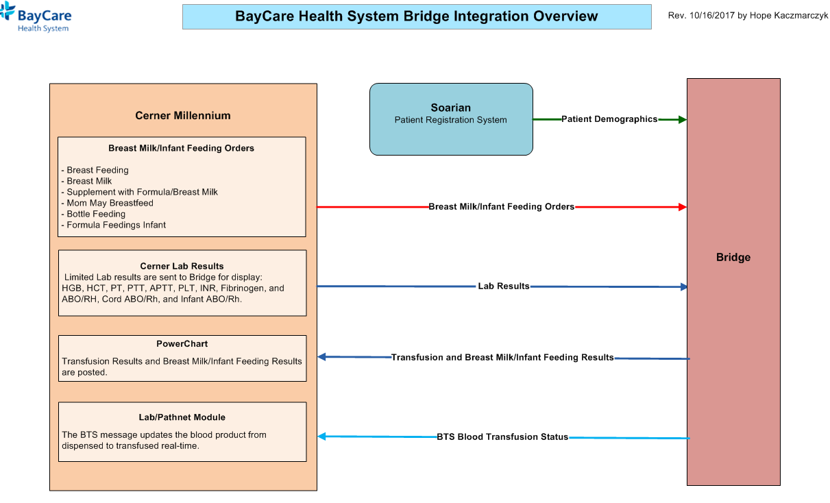

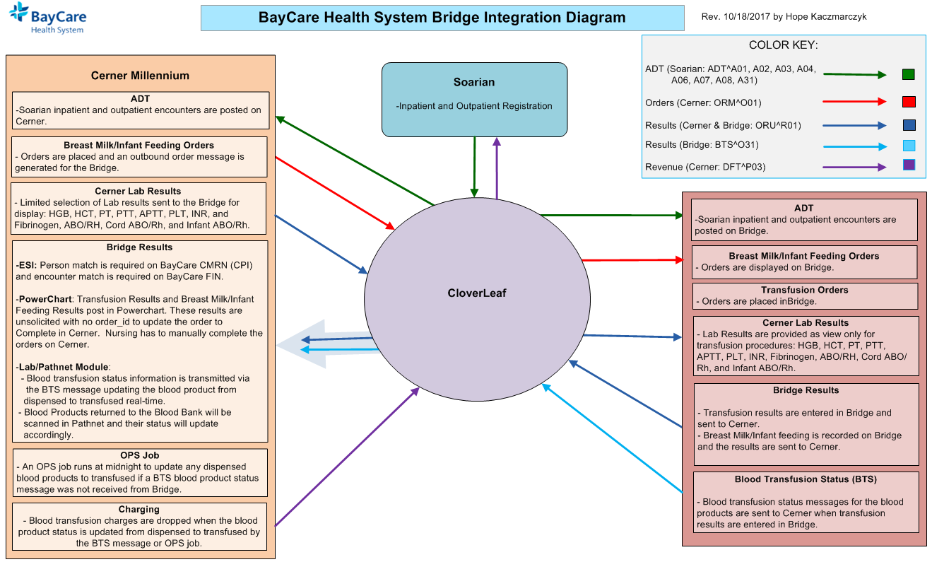

CloverLeaf Threads for Bridge Results outbound to Cerner on CloverLeaf Site: cerner_results_7_p

# 3. Requirements

## 3.1 Functional Requirements

|  |  |  |
| --- | --- | --- |
| **Cloverleaf** |  |  |
| **Number** | **Requirement Name** | **Requirement Description** |
| FR.2018.1.0 | No result with a missing patient CPI should go to Cerner. | The CPI is used by Cerner FSI for load balancing and missing CPIs cause the Cerner interface to stall. A TCL advanced filter is used in Cloverleaf to kill any message where the CPI in PID.2 is null. |
|  |  |  |
| FR.2018.2.0 | Send the BayCare CPI in PID.2 | The BayCare CPI will be sent in PID.2, and the ID Type Code in PID.2.5 should be hardcoded to “BCCPI”. |
| FR.2018.3.0 | Send the BayCare MRN in PID.3 | The BayCare MRN will be sent in PID.3, and the ID Type Code in PID.3.5 should be hardcoded to “BCMRN”. |
| FR2018.4.0  FR2018.5.0 | Send the account number in  PID.18  Suppress the PV1 segment in the output to Cerner | The account (FIN) number is sent in PID.18; the ID Type Code in PID.18.5 should be hardcoded to “BCFN”.  The dynamic locations sent by Bridge in PV1.3 do not exist in Cerner and would cause issues. The PV1 segment is optional in Cerner and is not necessary for the message to file properly. |

|  |  |  |
| --- | --- | --- |
| **Cerner** |  |  |
| **Number** | **Requirement Name** | **Requirement Description** |
| FR.2018.01.1  FR.2018.01.2 | New Contributor System: BRIDGE  **New Cerner Contributor Source:**  BRIDGE | The BRIDGE contributor system was created on Cerner to handle the breast milk/infant feeding orders and limited Lab results sent outbound along with the breast milk/infant feeding, transfusion, and blood product disposition results sent inbound.  BRIDGE is a bi-directional contributor system:  - Organization: BayCare Health System  - Contributor System Type: Unauth  - Contributor Source: BRIDGE  - Alt Contributor Source: Invision  - Message Format: HL7 Standard V2.x  **Special Configurations**:  - Clincal Event processing done using order catalog/DTA.  Note: This setting was required for the Blood Product Volume DTAs (aliased on code set 14003 for contributor source BRIDGE) and linked to their corresponding event codes on code set 72 for proper processing in Nursing and Lab-Pathnet Applications.   * Blood Priduct DTAs: * PLT Volume * WB Volume * RBC Volume * FFP Volume * CRYO Volume * GRAN Volume * OTH Volume   **ESI Alias Translation**:  - PID-02 External Person Id (Type: CMRN, ESI Alias Type:  BCCPI, Alias Pool: BayCare CMRN)  - PID-03 Internal Person Id (Type: MRN, ESI Alias Type:  BCMRN, Alias Pool: BayCare MRN)  - PID-18 Patient Account Number (Type: FIN NBR, ESI Alias  Type: BCFN, Alias Pool: BayCare FIN)  -ORC/OBR-03 Filler Order Id (Type: Internal Accession Number)  **ESI Ensure Parameters**:  - Person = Exist or Fail Ensure  - Encounter = Exist or Fail Ensure  - Event = Update ensure  **Person Match**:  - Alias of BayCare CMRN = Match Required  **Encounter Match**:  - Alias of BayCare FIN = Match Required  **Personnel Alias**:  - All Personnel = ORGANIZATION DOCTOR (Alias Pool: BayCare  Dr Number)  **Order Match:**  **-** Internal Accession Number = Match Required  The contributor system, Bridge, uses BayCare’s main contributor source Invision aliases for most code sets. The contributor source of BRIDGE is used for result, Blood Bank Processes, and DTA inbound aliases sent by the Bridge Solution:  - Blood Product Volume DTAs in code set 14003  - Result items (event codes) in code set 72  - The alias sent in OBR.4 needs to be assigned as the alias to the  code value with the CDF Meaning of TRANSFUSE in code set  16089.  - Blood Bank Process of Transfuse in code set 1664 (for BTS  messages) |
|  |  |  |
| FR.2018.01.3 | New ComServer:  ORU_TCP_BRIDGE_IN  with Type script: bridge_in_typescript  and standard_ack script | Only one interface was set up on the Cerner side for both, the breast milk-infant feeding/transfusion ORU messages and the blood product disposition BTS messages. To accommodate multiple message types on one interface, a Type script was written and attached to the new comserver, ORU_TCP_BRIDGE_IN:  bridge_in_typescript , Type script:   * Sets the message type/trigger since this interface is receiving/processing both, ORU and BTS, messages. The script sets:   oen_reply->type = concat("BTS", char(0))  oen_reply->trigger = concat("O31", char(0))  or  oen_reply->type = concat("ORU", char(0))  oen_reply->trigger = concat("R01", char(0))  standard_ack script:   * Standard script used to reply ack/nack messages back to CloverLeaf when the message is received on Cerner. |
| FR.2019.07 | Bridge feed from Cerner is no  Longer a dedicated feed. It comes in on the Cerner Unified reulsts feed | Uses uses proc tpscernercommon code,    Setting default calue of MSH.5.1 to PV1.3.7  Over ride MSH.5 if PV1.18 =JHOUTREACH, hard code SJH to MSH.5.  If PV1.18 =WOOUTREACH, hard code WHH to MSH.5 and PV1.18 =MPOUTREACH, hard code MPH to MSH.5.  Remove patient email from PID.11  Iterate through PID.11 looking for Home address and populate just these values outbound in PID.11  Blank our PID.19 is SSN=999999999  Replace & character with the word ‘and’ in OBR.13, OBR.27.7 and OBR.31.2.     |  |  | | --- | --- | | tpsCernerLabResultsModifier | Null PID.5.7  Null various PV1.19 visit number fields:  PV1.19.2  PV1.19.3  PV1.19.4.1  PV1.19.4.2  PV1.19.4.3  PV1.19.5  PV1.19.6.1  PV1.19.6.2  PV1.19.6.3  Swap various ORC.2 and ORC.3 fields:  ORC.2.1 and ORC.3.1  ORC.2.2 and ORC.3.2  ORC.2.3 and ORC.3.3  ORC.2.4 and ORC.3.4  Swap various OBR.2 and OBR.3 fields:  OBR.2.1 and OBR.3.1  OBR.2.2 and OBR.3.2  OBR.2.3 and OBR.3.3  OBR.2.4 and OBR.3.4  If OBX.3.3 =LOINC, swap OBX.3.4 with OBR.3.1 and swap OBX.3.5 with OBX.3.2.  Else, swap OBX.3.4 and OBX.3.1, OBX.3.5 and OBX.3.2 and OBX.3.6 and OBX.3.3. | |

## 3.2 Messaging Protocols

Below are listed the details for the messaging protocols that will be leveraged for this integration. Please see the reference document located on the Integration SharePoint server.

### 3.2.1 Inbound to the BayCare Cloverleaf From Bridge

* TCP MLLP Server Connection
  + HL7 2.3 ORU messages from Bridge to CloverLeaf

### 3.2.2 Outbound to Cerner

* TCP MLLP Client Connection
  + HL7 2.3 ORU messages from Cloverleaf to Cerner

# 4. HL7 Messaging

## 4.1 Messaging Format

### 4.1.1 Segments

The segments utilized for this interface are:

MSH

PID

PV1

OBR

{OBX}

*Message Construction Notes:*

*[Square Brackets] – Optional*

*{Curly Brackets} – Repeatable*

*MSH – Message Header*

*PID – Patient ID segment*

*PV1 – Patient Visit segment*

*OBR – Observation request segment*

*OBX – Observation/Result segment*

### 4.1*.*2 Messaging Event Types

Below are the messages types necessary for this integration

Supported ORU Events

|  |  |
| --- | --- |
| **Event Type** | **Description** |
| R01 | Discrete, Unsolicited Result Message from Bridge to Cerner |

4.1*.*3 Cloverleaf Configuration Files

For each HL7 interface specified in Section 2 of this document, identify the Cloverleaf Configuration Files: Variants, TCL Scripts, Xlates, etc.

HL7 Variants: 2.3 cerner_emr

Xlate: bridge_cerner_oru.xlt

TCL: tpsAdvHL7Filter.tcl, tpsHL7FilterSegment

### 4.1.4 Cloverleaf Site Location

Production = cerner_results_7_p

Test = cerner_results_7

## 4.2 Data Transformation Requirements

| **Field Description** | **HL7 Field Loc.** | **Required R/O/C** | **Data Type** | **Length** | **Notes** |
| --- | --- | --- | --- | --- | --- |
| **All Segments** | **MSH, PID, PV1, OBR, OBX** | R |  |  | CloverLeaf: BULKCOPY |
| Receiving Application | MSH.5 | O |  |  | CloverLeaf: Hardcode “HNAM” |
| **Patient Identifier Segment** | **PID** | R |  |  |  |
| PID.2 (CPI) ID Type Code | PID.2.5 | R |  |  | CloverLeaf: Hardcode “BCCPI” |
| PID.3 (MRN) ID Type Code | PID.3.5 | R |  |  | CloverLeaf: Hardcode “BCMRN” |
| PID.18 (FIN) ID Type Code | PID.18.5 | R |  |  | CloverLeaf: Hardcode “BCFN” |

**Note: No data transformation done on Cerner.**

## 4.3 Sample Message

Inbound to Cloverleaf from Bridge: (Blood transfusion result)

MSH|^~\&|BRIDGE|BRIDGE|CERN|CERN|20180104140658||ORU^R01|636506716188523507|P|2.3

PID||810015876|7000016611||BMTRANSFUSIONSEVEN^TESTSEVEN||19620501000000|M||||||||||6000035751|0

PV1|||C3T1^C303^A

OBR|||904837940117532|Transfusion Result|||20180104140647|||JKH46827^Holz, Jane k|C||||||||||||||F

OBX|1|ST|Blood Product|E0382|AS-3 RBC LR 500||||||F|||20180104140647

OBX|3|ST|Comment||Test checks and no dispense||||||F|||20180104140647

OBX|4|ST|Donation Type|V|Volunteer homologous (allogeneic) donor||||||F|||20180104140647

OBX|5|NM|RBC Volume||350|mL|||||F|||20180104140647

OBX|6|ST|Unit Number||END W036817878964||||||F|||20180104140647

OBX|7|ST|Post Checks 1||Chills||||||F|||20180104140647

OBX|8|ST|Post Checks 2||Fever||||||F|||20180104140647

OBX|9|ST|User ID||Holz, Jane k^JKH46827||||||F|||20180104140647

OBX|10|ST|End Date Time||01/04/2018 14:06||||||F|||20180104140647

Outbound from Cloverleaf to Cerner: (Blood transfusion result)

MSH|^~\&|BRIDGE|BRIDGE|HNAM|CERN|20180104140658||ORU^R01|636506716188523507|P|2.3

PID||810015876^^^^BCCPI|7000016611^^^^BCMRN||BMTRANSFUSIONSEVEN^TESTSEVEN||19620501000000|M||||||||||6000035751^^^^BCFN|0

OBR|||904837940117532|Transfusion Result|||20180104140647|||JKH46827^Holz, Jane k|C||||||||||||||F

OBX|1|ST|Blood Product|E0382|AS-3 RBC LR 500||||||F|||20180104140647

OBX|3|ST|Comment||Test checks and no dispense||||||F|||20180104140647

OBX|4|ST|Donation Type|V|Volunteer homologous (allogeneic) donor||||||F|||20180104140647

OBX|5|NM|RBC Volume||350|mL|||||F|||20180104140647

OBX|6|ST|Unit Number||END W036817878964||||||F|||20180104140647

OBX|7|ST|Post Checks 1||Chills||||||F|||20180104140647

OBX|8|ST|Post Checks 2||Fever||||||F|||20180104140647

OBX|9|ST|User ID||Holz, Jane k^JKH46827||||||F|||20180104140647

OBX|10|ST|End Date Time||01/04/2018 14:06||||||F|||20180104140647

Inbound to Cloverleaf from Bridge: (Breast milk adminnistration result)

MSH|^~\&|BRIDGE|BRIDGE|CERN|CERN|20171227155226||ORU^R01|636499867465700137|T|2.3

PID||810015874|7000016609||BMMDONORMILKFOUR^BABYTESTFOUR||20171106114500|M||||||||||6000035725|0

PV1|||3NSY^3109^A

OBR|||BMM174|Administer|||20171227155226|||B092167^Marshall, Abbie|||||||||||||||F

OBX|1|ST|Bottle Number||174||||||F|||20171227155226

OBX|2|ST|Expiration Date||12/28/2017 15:51||||||F|||20171227155226

OBX|3|ST|Thaw Date||12/27/2017 15:51||||||F|||20171227155226

OBX|4|ST|Administer||Marshall, Abbie||||||F|||20171227155226

Outbound from Cloverleaf to Cerner: (Breast milk adminnistration result)

MSH|^~\&|BRIDGE|BRIDGE|HNAM|CERN|20171227155226||ORU^R01|636499867465700137|T|2.3

PID||810015874^^^^BCCPI|7000016609^^^^BCMRN||BMMDONORMILKFOUR^BABYTESTFOUR||20171106114500|M||||||||||6000035725^^^^BCFN|0

OBR|||BMM174|Administer|||20171227155226|||B092167^Marshall, Abbie|||||||||||||||F

OBX|1|ST|Bottle Number||174||||||F|||20171227155226

OBX|2|ST|Expiration Date||12/28/2017 15:51||||||F|||20171227155226

OBX|3|ST|Thaw Date||12/27/2017 15:51||||||F|||20171227155226

OBX|4|ST|Administer||Marshall, Abbie||||||F|||20171227155226

# Appendix A: Risks and Concerns

|  |  |  |  |  |  |
| --- | --- | --- | --- | --- | --- |
| **Project : Bridge** |  |  | | |  |
| **Number** | **Risk / Concern** | **Comment** | **Mitigation** | | |
| RC.2018.1.1 | Team Decision for the breast milk/infant feeding result ORU messages to not complete the orders on Cerner. These orders are parent orders with multiple feeding instructions and Nursing does not want the order to be completed after the first feeding result is entered. | Prior to Go-Live | | Nursing will handle completing the orders manually on Cerner. | |

# Appendix B: Issues List

| Issue  # | **Project: Bridge**  Issues | Cause/Assigned To | Resolution/Date Resolved | Comments |
| --- | --- | --- | --- | --- |
| 1 | Blood Product Volumes are not being processed properly on Cerner and are causing the final ORU message to fail. | Cerner 2018 Upgrade- assigned to Cerner. This is a non-FSI issue where the Blood Volume DTAs do not link to the event codes when built and attached using the front-end app-dcptools/DTA Wizard. The issue can not be fixed on the front end by deleting and re-establishing the link in Coreeventmanager.exe which was how this issue would have been fixed prior to the Cerner 2018 Upgrade. | Cerner created a CCL program to be used to resolve the issue at the present time. Please note this issue could occur with other Projects or Prod DTA changes and the CCL program would need to be used.  Cerner has stated that the issue will be fixed with a package scheduled for March of 2018 |  |  |

* End of document